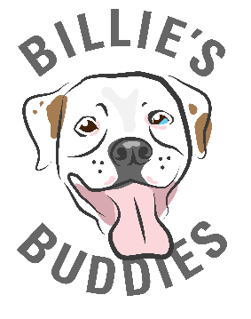
Fostering is an essential part of Billie’s Buddies, and we couldn’t be more grateful for your support! Once you complete the foster application, please email the document to BilliesBuddiesAnimalRescue@gmail.com.
To be considered as a foster you must:
- Have the knowledge and consent of your landlord (if renting).
- Be willing to work with the animal(s) to help them get ready for adoption. This includes housebreaking, basic training, socialization, etc.
- Agree to help us find a permanent home for the foster animal(s) and be willing to allow prospective adopters meet the animal.

Full name: ______________________________ Age: ______ Occupation:_________________________
Home address: ________________________________________________________________________
Phone #: __________________________ Email: _____________________________________________
Best way to reach you: Call ___ Text ___ Email ___
Housing type: House ___ Apartment ___ Condo ___ Other ___
Does your home have any of the following? Check all that apply:
Patio___ Pet Door ___ Pool ___ Back yard (fenced) ___ Back yard (not fenced) Front yard ___
(If Rental) Is there a pet policy/fee? ___ Landlord name and phone: ______________________________
Number of adults in household: _____ Number of children in household (with ages): ________________
How often are you at home? Most of the time ___ Some of the time ___ Barely ___
In what areas of your home will your foster be allowed? _______________________________________
Where will this foster spend most of their time? Crate ___ Indoors ___ Outdoors ___ Other ___
Where will this foster sleep at night? _______________________________________________________
List all current pets, including breed, that live with your family: _________________________________
(If Applicable) Are your current pets up to date on vaccines? Yes ___ No ___ I don’t know ___
(If Applicable) Are your current pets spayed/neutered? Yes ___ No ___ I don’t know ___
(If Applicable) Are your current pets on heartworm & flea preventative? Yes ___ No ___ I don’t know __
Veterinarian Name/Practice: ________________________ Vet Phone Number: ____________________
What type of animal(s) would you like to foster? (Check all that apply)
Young un-weaned kittens with mom ___ Weaned kittens ___ Adult cats ___
Young un-weaned puppies with mom ___ Weaned puppies ___ Adult dogs ___
How long are you willing to foster at any one time? ___________________________________________
Are you willing to foster more than one animal? ___
Any foster pet you take needs to get along with (check all that apply): Dogs ___ Cats ___ Kids ___
Have you ever given medication to a sick animal before? ___
Have you ever fostered a pet before? ___ If yes, which organization? _____________________________
Are you aware that it may take the animal some time to decompress and adjust to their new environment? ___

By signing you agree that all of the information you have provided is true and correct to the best of your knowledge. If at any point the information above changes, or you are no longer able to care for the animal, you will immediately contact Billie’s Buddies. You agree that you are fostering the animal for Billie’s Buddies, and do not have any right of ownership over the foster animal. You agree to immediately return any foster animal in my care to Billie’s Buddies at the request of its authorized representative at any time and for any reason. If you refuse or fail to comply with any provision of this agreement, Billie’s Buddies has the right to terminate this agreement and has the right to the immediate surrender and return of my foster animal(s).

____________________________________________________ _________________________
Signature of Applicant Date

